Bisection Method

P= a+ b /2

Fixed-Point Iteration

To find a solution to p = g( p) given an initial approximation p0: INPUT initial approximation p0; tolerance TOL; maximum number of iterations N0. OUTPUT approximate solution p or message of failure.

Step 1 Set i = 1

Step 2 While i ≤ N0 do Steps 3–6.

Step 3 Set p = g( p0). (Compute pi.)

Step 4 If | p − p0| < TOL then OUTPUT ( p); (The procedure was successful.) STOP.

Step 5 Set i = i + 1.

Step 6 Set p0 = p. (Update p0.)

Step 7 OUTPUT (‘The method failed after N0 iterations, N0 =’, N0); (The procedure was unsuccessful.) STOP.

Newton Rapson

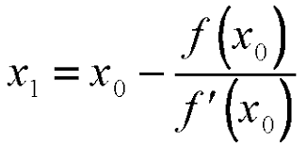

Regular Falsi & Secant :

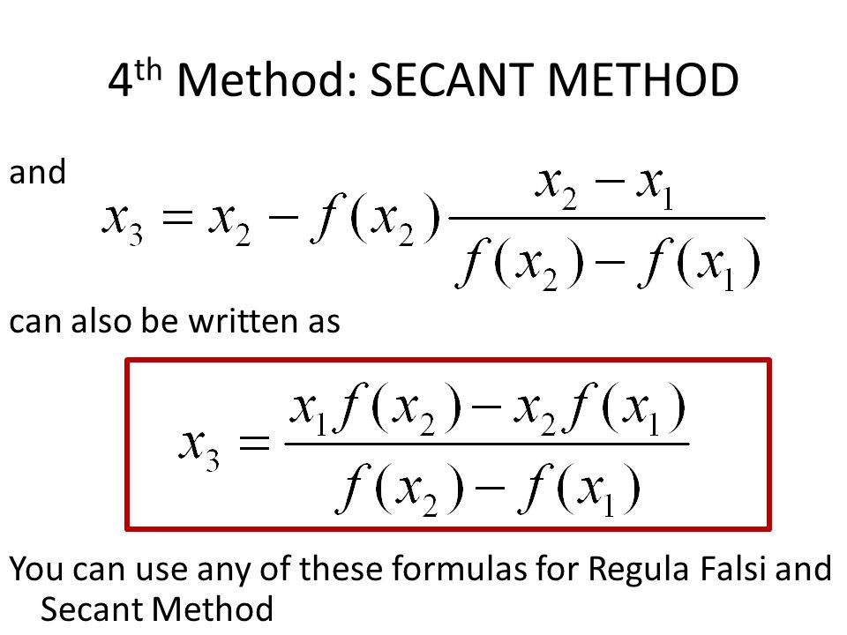

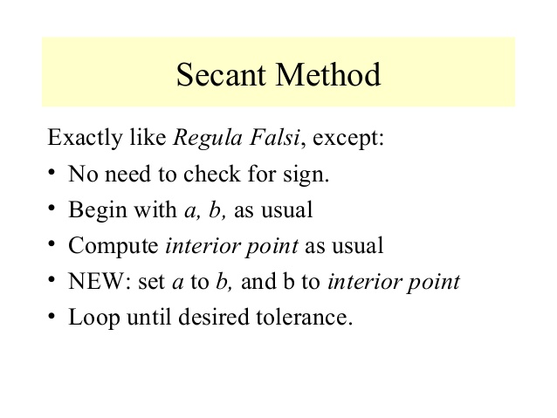

Lagrange interpolation polynomial:

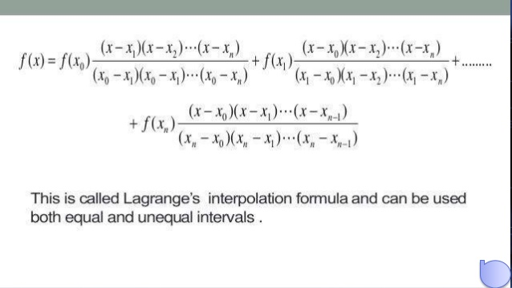

Newton’s Divided-Difference Formula

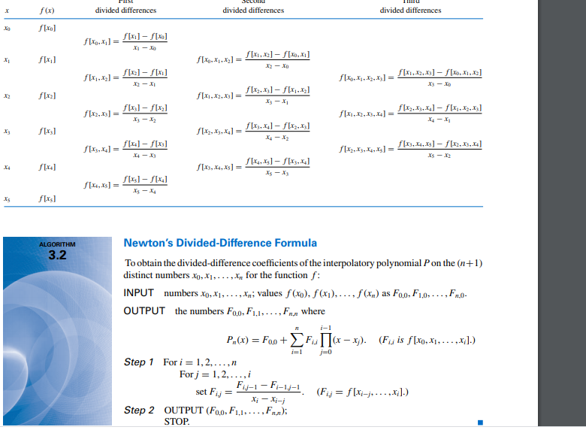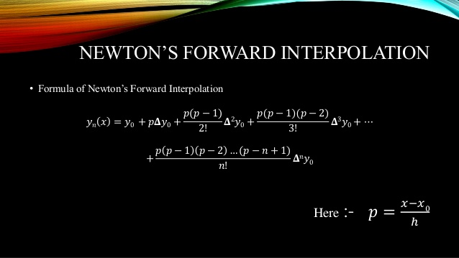

Newton Center

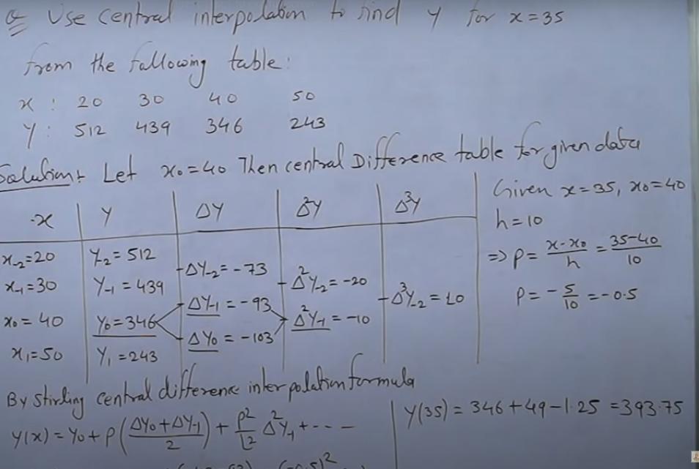

Differentiation using Forward and Backward differences

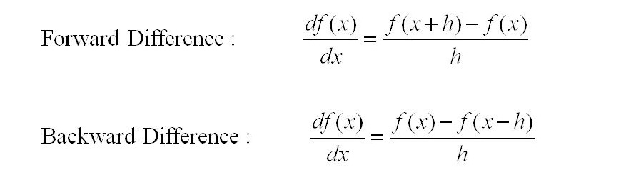

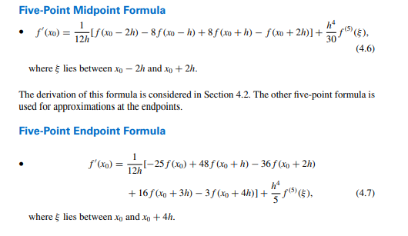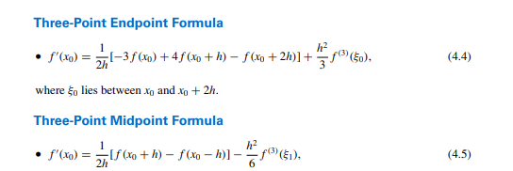

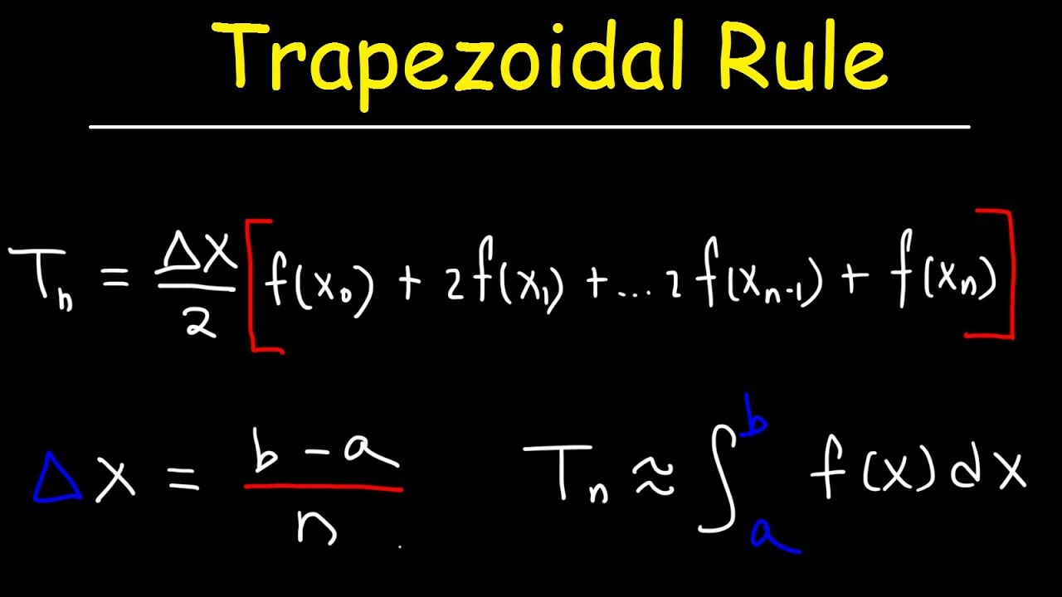

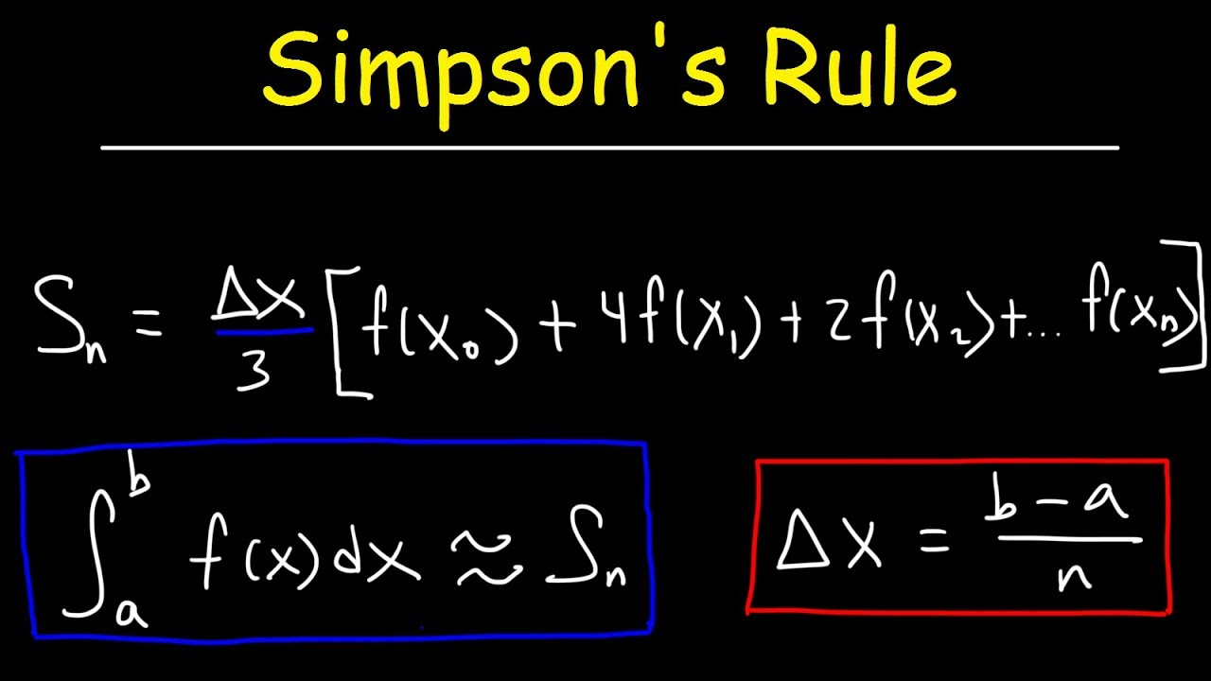

Closed Newton Cotes

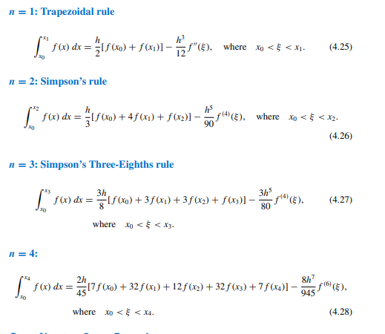

Open Newton Cotes

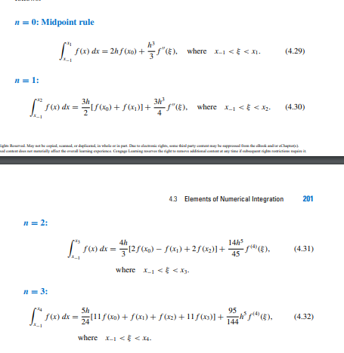

Composite

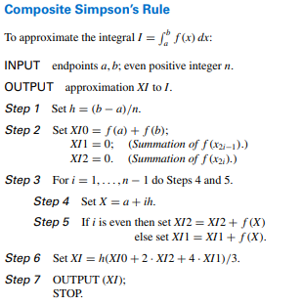

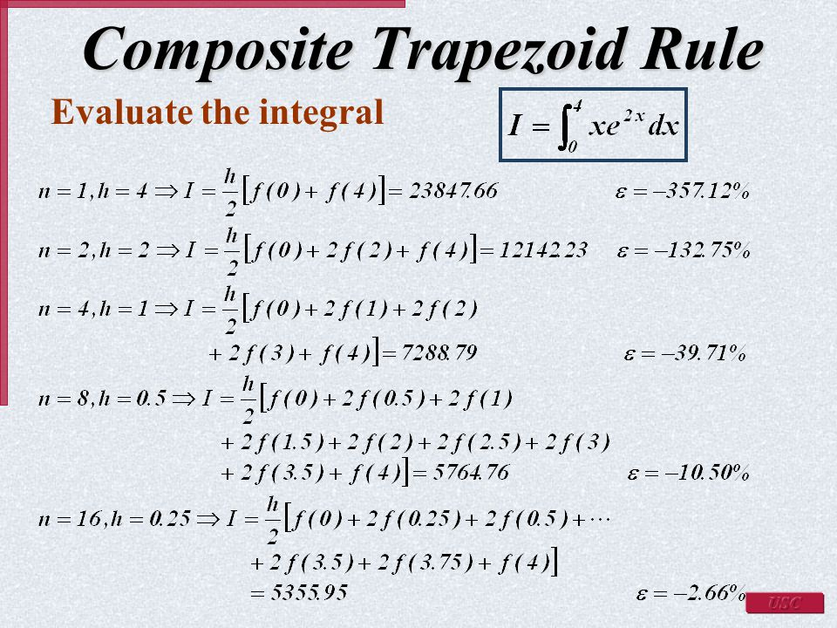

Euler

